WEEK ONE - Subject: Learn to Share Your Faith in a World That Isn’t Listening

Dear Pastors and Church Leaders,

Have you ever felt like you’re speaking truth, but no one is hearing it? That in our culture today, the noise, distractions, and even hostility make it harder than ever to share the hope of Christ?

You’re not alone—and there is a way forward.

We invite you to join us for a free, dynamic webinar designed to equip you and your congregation to share your faith with fresh passion and confidence, even when the world seems to have tuned out.

Webinar Details:

- Part 1: Thursday, September 11 at 12:00 PM (EST)
- Part 2: Thursday, October 2 at 12:00 PM (EST)

In just one hour, you’ll:

- Discover new approaches to evangelism that connect with hearts and minds today.
- Learn practical tools you can use immediately in your own conversations and ministries.
- Be inspired to lead your people in living and sharing the Good News with boldness and love.

This isn’t just another program. It’s a chance to step into your calling as a leader who equips the Church for the mission Jesus gave us: to make disciples.

👉 Reserve your spot now: https://tinyurl.com/ybpz9yuw

We’re excited to walk alongside you and your church in this vital conversation. The world needs the hope of Christ—and we believe He will use you powerfully to share it.

Serving with you,
[Your Name]
[Your Title/Organization]

This event is made possible at no cost to you thanks to the generous sponsorship of Great Commission Fellowship and Ascent.

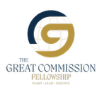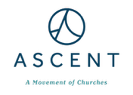

WEEK TWO - Subject: 95% of Christians have never shared their faith. Let’s change that.
Dear Pastors and Church Leaders,
Did you know that 95% of Christians have never led someone to Christ? And that nearly half of practicing believers say they feel unsure or unequipped when it comes to sharing their faith?
In a world that desperately needs hope, we can’t afford to stay silent—or stuck.
That’s why we’re inviting you to a free, 2-part webinar designed to equip and empower you—and your people—to share the Gospel with clarity, conviction, and love.

Webinar Details:

- Part 1: Thursday, September 11 at 12:00 PM (EST)
- Part 2: Thursday, October 2 at 12:00 PM (EST)

In just one hour, you’ll:
- Learn how to share the Good News in ways that resonate with today’s culture
- Walk away with tools and ideas you can use immediately in your church and community
- Be reminded that evangelism isn’t just possible—it’s powerful, even in a distracted world
👉 Reserve your spot now: https://tinyurl.com/ybpz9yuw
This is your chance to help your church rediscover its voice—and its mission.
Serving with you,
[Your Name]
[Your Title/Organization]
This event is made possible at no cost to you thanks to the generous sponsorship of Great Commission Fellowship and Ascent.

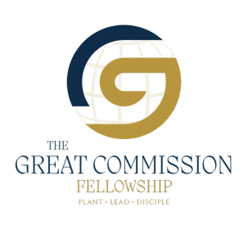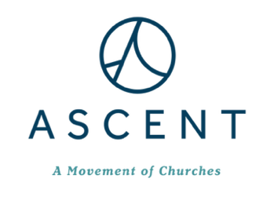

WEEK THREE - Subject: What do you do when people stop listening?
Dear Pastors and Church Leaders,
You preach the Gospel. You serve faithfully.
But sometimes… it feels like the world just isn’t listening.
If you’ve ever felt discouraged by the silence—or unsure of how to break through it—you are not alone.
This is exactly why we’re hosting a free, 2-part webinar to explore how we can share the Good News now—in a culture that’s tuned out or turned away.

Webinar Details:

- Part 1: Thursday, September 11 at 12:00 PM (EST)
- Part 2: Thursday, October 2 at 12:00 PM (EST)

In just one hour, you’ll be encouraged, equipped, and reminded of this truth:
The Gospel still speaks. We just need to learn how to speak it in today’s language.
👉 Register today: https://tinyurl.com/ybpz9yuw
This isn’t just another webinar—it’s a moment to reignite your mission.
We hope to see you there,
[Your Name]
[Your Title/Organization]
This event is made possible at no cost to you thanks to the generous sponsorship of Great Commission Fellowship and Ascent.

WEEK FOUR - Subject: The first session is almost here—are you registered?
Dear Pastors and Church Leaders,
The countdown is on! Our 2-part evangelism webinar begins next week, and we’d love for you—and your church leaders—to be part of it.
Whether you’re looking for fresh language, practical tools, or just renewed encouragement, this session is for you.

Webinar Details:

- Part 1: Thursday, September 11 at 12:00 PM (EST)
- Part 2: Thursday, October 2 at 12:00 PM (EST)

👉 Register today: https://tinyurl.com/ybpz9yuw
Let’s rediscover how to speak the Gospel in a world that’s stopped listening.
We believe you’ll walk away inspired—and ready to lead others to do the same.
See you soon,
[Your Name]
[Your Title/Organization]
This event is made possible at no cost to you thanks to the generous sponsorship of Great Commission Fellowship and Ascent.

