70 COMMUNITY SERVICE PROJECT IDEAS

**Helping the place you love, doing the things you love.**



**Jackie Menjivar**

Content Writer

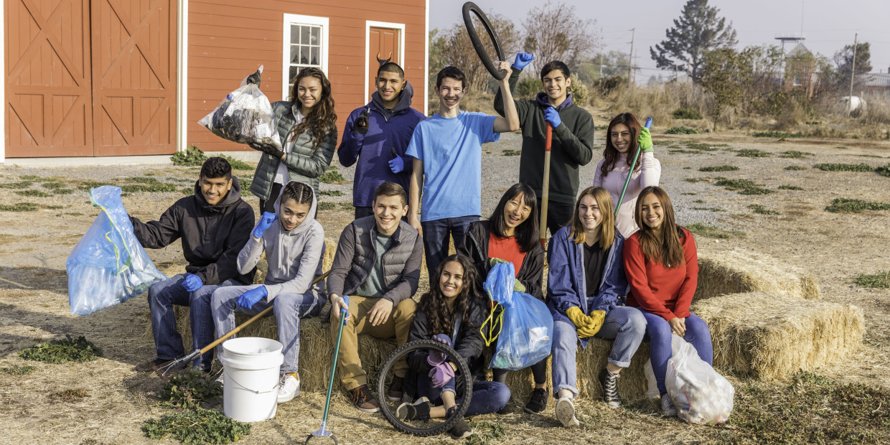

Community service is exactly what it sounds like: services that you do to benefit your community. If that sounds a little broad, it’s because it is -- community service can take a lot of different forms since there’s SO much you can do to help folks out in your area.

But that might leave you wondering where to start. (Spoiler alert: *this* is where you start!) We’ve put together a list of community service project ideas, organized by what you’ll be doing. Whether that’s collecting, teaching, volunteering, or something else, you should be able to find something to inspire you to get out there and *do*.

**Collect Things for Your Community:**

If you look around your community, you’ll probably find at least a few places that accept donations -- like food pantries, family shelters, and schools, just to name a few. Here’s a super comprehensive guide on [running your own donation drive](https://www.volunteerfairfax.org/wp-content/uploads/2019/03/DonateNow-The-Donation-Drive-Planning-Kit.pdf), and here are some [places that accept donations](https://www.move.org/how-to-donate-your-used-items/).

1. Collect school supplies.
2. [Collect backpacks.](https://www.dosomething.org/us/campaigns/backpack-attack)
3. Collect grocery coupons for local food pantries to help them with costs.
4. [Collect non-perishable food items.](https://www.dosomething.org/us/campaigns/supermarket-stakeout)
5. Collect unused makeup to donate to domestic violence shelters.
6. [Collect Halloween candy](https://www.dosomething.org/us/campaigns/treats-troops) to send to deployed military service members who can’t be home to celebrate.
7. Collect hygiene products.
8. [Collect gently-used jeans](https://www.dosomething.org/us/campaigns/teens-jeans) for teenagers in homeless shelters.
9. Collect stuffed animals.
10. [Collect SAT books](https://www.dosomething.org/us/campaigns/sat-book-donation) and donate them to a library.

**Do Things for Your Community:**

Some of these take a few minutes, and others a bit longer, but they all help out in some way. Especially try pitching in to do tasks for neighbors who can’t do them themselves, like folks who are ill, elderly, or busy with work or childcare.

1. Walk kids home from school.
2. Rake leaves for an elderly neighbor.
3. Mow your neighbor’s lawn.
4. Offer dog-walking services.
5. If you know another language, be a translator at parent-teacher conferences.
6. Babysit during PTA meetings.
7. Foster a shelter animal.
8. Take and donate photos during community events.
9. Donate blood (if you’re at least 17, or 16 with parental consent).
10. Contact your reps about local issues.

**Teach Things to Your Community:**

We’ve all got things that we’re good at, so why not share those skills with others? If teaching feels a little intimidating at first, try using these tips for [teaching anything to anyone](https://www.inc.com/kevin-daum/how-to-teach-anything-to-anyone.html).

1. Help kids with their homework.
2. [Teach underclassmen safe social media practices.](https://www.dosomething.org/us/campaigns/social-media-makeover)
3. Give free music lessons.
4. Coach a youth sports team.
5. [Educate beachgoers about sustainability.](https://www.dosomething.org/us/campaigns/seaside-stakeout)
6. Teach adults in your life internet skills.
7. Give a seminar on driving safety.
8. Teach CPR (after getting certified).
9. Help English language learners practice with conversation.
10. Teach people how to register to vote.

**Fix Things in Your Community:**

If you see a problem in your community, consider doing something about it! Sometimes the best service we can do the places we love is to take care of them.

1. [Start a little, free library.](https://littlefreelibrary.org/build/)
2. [Place campfire safety plaques near campsites.](https://www.dosomething.org/us/campaigns/campfire-fighters)
3. Clean up your local park.
4. [Beautify your area with seed bombs.](https://www.dosomething.org/us/campaigns/seed-bombs-away)
5. Help a neighbor or community org paint fence or building.
6. Spruce up a run-down playground.
7. Help your neighbors with repairs.
8. Offer to patch up clothes and stuffed toys.
9. Organize books at the library.
10. Give IT help to local adults.

**Host Things in Your Community:**

Here’s your chance to flex your event-planning muscles and put on something that will bring folks together. After all, the only thing better than community service is doing it with friends.

1. Host a bake sale.
2. [Host a clothing swap.](https://www.dosomething.org/us/campaigns/clothing-go-round)
3. Host a holiday meal.
4. [Host a competitive book drive.](https://www.dosomething.org/us/campaigns/stacks-stacks)
5. Host activities for kids in hospitals.
6. [Host a dog wash.](https://www.dosomething.org/us/campaigns/scrub-dub-dog)
7. Host an immunization clinic.
8. Host a river clean-up.
9. [Host a gardening party.](https://www.dosomething.org/us/campaigns/planting-par-tay)
10. Host a study group.

**Make Things For Your Community:**

There’s something special about receiving a handmade gift, and we’re sure there are plenty of people and places that would really appreciate it. Make and send items to folks at elderly care facilities, family shelters, or hospitals to make their days a little brighter.

1. Knit scarves or hats for families in shelters.
2. Bake cookies and snacks for food pantries.
3. Write letters to seniors in care facilities.
4. Make quilts or blankets for kids in hospitals.
5. Build birdhouses for your neighbors.
6. Make Ramadan or Eid cards for your local mosque.
7. Design a community mural.
8. Put together first aid kits for local shelters.
9. Make birthday cards for kids in homeless shelters.
10. Produce a community newsletter.

**Volunteer For Things in Your Community:**

The cool thing about volunteering is that you can do it just about anywhere ([even online](https://www.dosomething.org/us/articles/9-places-to-volunteer-online-and-make-a-real-impact)!), so hopefully this gets you thinking. For more inspiration, we’ve got [a few other places you can volunteer](https://www.dosomething.org/us/articles/volunteer-opportunities-for-teens) and a bunch of volunteer opportunities with [DoSomething.org](https://www.dosomething.org/us).

1. Volunteer at your local library.
2. Volunteer to chaperone a field trip.
3. Volunteer with a local nonprofit.
4. Volunteer at an animal shelter.
5. Volunteer at a community center.
6. Volunteer as a lifeguard.
7. Volunteer to be a crossing guard.
8. Volunteer to do social media for a local org.
9. Volunteer to help set up a community event.
10. Volunteer at a food pantry.

RELATED ARTICLES

**[9 Places to Volunteer Online (And Make a Real Impact)](https://www.dosomething.org/us/articles/9-places-to-volunteer-online-and-make-a-real-impact" \t "_self)**

[Volunteering online lets you donate your virtual time to a cause space that matters. Learn how you can create IRL impact through online action.](https://www.dosomething.org/us/articles/9-places-to-volunteer-online-and-make-a-real-impact" \t "_self)

**[DOSOMETHING.ORG](https://www.dosomething.org/us/articles/9-places-to-volunteer-online-and-make-a-real-impact" \t "_self)**

**[8 Volunteer Opportunities for Teens in 2020](https://www.dosomething.org/us/articles/volunteer-opportunities-for-teens" \t "_self)**

### [Here are a few organizations with volunteer opportunities for teens that are tapping into the change-making potential of young people. 1.](https://www.dosomething.org/us/articles/volunteer-opportunities-for-teens" \t "_self)[[American Red Cross](https://www.dosomething.org/us/articles/volunteer-opportunities-for-teens" \t "_self)](https://www.redcross.org/)

[You may recognize the American Red Cross as the folks who provide disaster relief and organize blood donations, among other things. It’s important work, and, yes, you can get involved! Take a look at their](https://www.dosomething.org/us/articles/volunteer-opportunities-for-teens" \t "_self)[[youth volunteer opportunities](https://www.dosomething.org/us/articles/volunteer-opportunities-for-teens" \t "_self)](http://redcrossyouth.org/scholarships/be-a-volunteer/)[, and if you’re feeling inspired, you can even start your own](https://www.dosomething.org/us/articles/volunteer-opportunities-for-teens" \t "_self)[[Red Cross Club](https://www.dosomething.org/us/articles/volunteer-opportunities-for-teens" \t "_self)](http://redcrossyouth.org/college/how-to-start-a-red-cross-club-2/)[at your school.](https://www.dosomething.org/us/articles/volunteer-opportunities-for-teens" \t "_self)

### [2.](https://www.dosomething.org/us/articles/volunteer-opportunities-for-teens" \t "_self)[[Habitat for Humanity](https://www.dosomething.org/us/articles/volunteer-opportunities-for-teens" \t "_self)](https://www.habitat.org/)

[Everyone deserves to have a place they call home. By volunteering with Habitat for Humanity, you can play a role in building up your community (literally). Their](https://www.dosomething.org/us/articles/volunteer-opportunities-for-teens" \t "_self)[[Habitat Youth Programs](https://www.dosomething.org/us/articles/volunteer-opportunities-for-teens" \t "_self)](https://www.habitat.org/volunteer/near-you/youth-programs)[accept volunteers between the ages of 5 and 40 for everything from home construction to affordable housing advocacy.](https://www.dosomething.org/us/articles/volunteer-opportunities-for-teens" \t "_self)

### [3.](https://www.dosomething.org/us/articles/volunteer-opportunities-for-teens" \t "_self)[[The Humane Society](https://www.dosomething.org/us/articles/volunteer-opportunities-for-teens" \t "_self)](https://www.humanesociety.org/)

[Whether you’re a dog person or a cat person (or a...hamster person?), you can join the Humane Society in their fight against animal cruelty.](https://www.dosomething.org/us/articles/volunteer-opportunities-for-teens" \t "_self)[[Find volunteer opportunities in your state](https://www.dosomething.org/us/articles/volunteer-opportunities-for-teens" \t "_self)](https://www.humanesociety.org/volunteer)[, and get involved in outreach, phone banking, or helping out at a local shelter.](https://www.dosomething.org/us/articles/volunteer-opportunities-for-teens" \t "_self)

### [4.](https://www.dosomething.org/us/articles/volunteer-opportunities-for-teens" \t "_self)[[Key Club](https://www.dosomething.org/us/articles/volunteer-opportunities-for-teens" \t "_self)](https://www.keyclub.org/)

[As the oldest service program for high schoolers, the Key Club has quite a history of helping teens get involved in volunteering. Because clubs are student-led, you get a direct say in the kinds of service projects you want to do. Chances are, there’s already a chapter in your school, but if not, you can try](https://www.dosomething.org/us/articles/volunteer-opportunities-for-teens" \t "_self)[[taking the lead on one](https://www.dosomething.org/us/articles/volunteer-opportunities-for-teens" \t "_self)](https://www.keyclub.org/membership/how-to-start-a-club/)[.](https://www.dosomething.org/us/articles/volunteer-opportunities-for-teens" \t "_self)

### [5.](https://www.dosomething.org/us/articles/volunteer-opportunities-for-teens" \t "_self)[[Meals on Wheels](https://www.dosomething.org/us/articles/volunteer-opportunities-for-teens" \t "_self)](https://www.mealsonwheelsamerica.org/)

[For those teens who just got their license and love any reason to get behind the wheel, here’s a volunteer opportunity that’ll make driving worthwhile. Meals on Wheels is on a mission to meet the nutritional and social needs of seniors. 225 million meals have been delivered so far --](https://www.dosomething.org/us/articles/volunteer-opportunities-for-teens" \t "_self)[[connect with your local provider](https://www.dosomething.org/us/articles/volunteer-opportunities-for-teens" \t "_self)](https://www.mealsonwheelsamerica.org/find-meals)[to find out how you can get involved.](https://www.dosomething.org/us/articles/volunteer-opportunities-for-teens" \t "_self)

### [6.](https://www.dosomething.org/us/articles/volunteer-opportunities-for-teens" \t "_self)[[Best Buddies](https://www.dosomething.org/us/articles/volunteer-opportunities-for-teens" \t "_self)](https://www.bestbuddies.org/)

[Volunteer with Best Buddies to help end the social, physical, and economic isolation of 200 million people with intellectual and developmental disabilities -- and you’ll make some new pals in the process! Join a school chapter (or](https://www.dosomething.org/us/articles/volunteer-opportunities-for-teens" \t "_self)[[start your own](https://www.dosomething.org/us/articles/volunteer-opportunities-for-teens" \t "_self)](https://www.bestbuddies.org/bbu/start-a-chapter/)[) to use friendship as a tool for inclusivity in your community.](https://www.dosomething.org/us/articles/volunteer-opportunities-for-teens" \t "_self)

### [7.](https://www.dosomething.org/us/articles/volunteer-opportunities-for-teens" \t "_self)[[Sierra Club](https://www.dosomething.org/us/articles/volunteer-opportunities-for-teens" \t "_self)](https://www.sierraclub.org/)

[Over 3.5 million Sierra Club members are fighting for the Earth, and you can become one of them! They even have a youth-specific](https://www.dosomething.org/us/articles/volunteer-opportunities-for-teens" \t "_self)[[Sierra Student Coalition](https://www.dosomething.org/us/articles/volunteer-opportunities-for-teens" \t "_self)](https://www.sierraclub.org/youth)[that empowers teens and young adults volunteering for climate justice. Clean up outdoor spaces, lead nature outings, or lend your voice to environmental campaigns.](https://www.dosomething.org/us/articles/volunteer-opportunities-for-teens" \t "_self)

**[DOSOMETHING.ORG](https://www.dosomething.org/us/articles/volunteer-opportunities-for-teens" \t "_self)**

**[7 Volunteering Ideas to Help the Environment](https://www.dosomething.org/us/articles/volunteering-ideas-to-help-the-environment" \t "_self)**

[Join the growing movement to protect our planet with these seven environmental volunteering ideas.](https://www.dosomething.org/us/articles/volunteering-ideas-to-help-the-environment" \t "_self)

**[DOSOMETHING.ORG](https://www.dosomething.org/us/articles/volunteering-ideas-to-help-the-environment" \t "_self)**

**[Summer Volunteering Programs for High School Students](https://www.dosomething.org/us/articles/summer-volunteering-programs-for-high-school-students" \t "_self)**

[From conservation to education, learn about some of the different kinds of summer volunteering](https://www.dosomething.org/us/articles/summer-volunteering-programs-for-high-school-students" \t "_self)