Social Media Post Samples & Most Effective Post Times

🌟 Best Overall Times to Post on Facebook:
Sun. (9a-11a), M./Tu. (9a-1p), W. (11a-1p). Th. (10a-12p), F. (9a-11a), Sat. (10a-11a)

Top Posting Tips for Churches/Nonprofits:
- Avoid late nights. Engagement typically drops after 8 PM.
- Use Facebook Insights to track when your specific audience is most active (check Meta Business Suite > Insights > Audience).
- Consistency beats randomness. Post at similar times each week for better performance.
- If promoting events, post 10–14 days out, then again 7 days, 3 days, and the day before (each with a different angle).

For Your Webinar Campaign: Given your church audience and topic:
- Best Days to Post: Tuesday, Wednesday, or Thursday
- Best Times to Post: Between 10:00 AM and 12:30 PM (EST)
- Add a follow-up/”last chance” post: 24–36 hours before each session, preferably Tuesdays at 11 AM

🌟 Best Overall Times to Post on Instagram:
Sun. (9a-11a), M. (10a-12p), Tu. (9a-1p), W. (10a-12p). Th. (11a-1p), F. (9a-11a), Sat. (10a-11a)

Top Instagram Tips for Ministry or Event Promotion
- Reels do well almost any time, but especially before 1 PM on weekdays.
- Stories perform better mornings and evenings—post them between 9–11 AM or 6–8 PM.
- Avoid posting after 8:30 PM, as engagement tends to drop off.
- Use countdown stickers and polls in stories to boost interest for upcoming events like your webinar.

For Your Webinar Promotion (Strategy Suggestion):
- Reels or carousel: Post Tuesdays or Thursdays at 10:30 AM
- Stories with countdowns: Post Mondays and Wednesdays by 10 AM
- Final Reminder Story: Post Wednesday morning (day of Part 1 or Part 2), between 8:30–9:30 AM

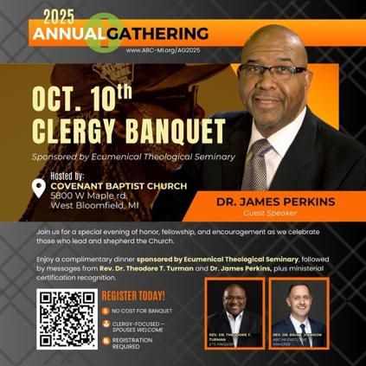

📅 Friday, October 10 | Covenant Baptist Church, West Bloomfield
Clergy, you’re invited to a night of honor, fellowship, and encouragement at our Clergy Banquet—sponsored by Ecumenical Theological Seminary. 🕊️

Enjoy a complimentary dinner, hear powerful messages from Rev. Dr. Theodore T. Turman and Dr. James Perkins, and celebrate ministry milestones with ministerial recognition. Spouses are warmly welcome!

👉 Registration is free but required. Secure your spot today: https://tithe.ly/event-registration/#/10336385

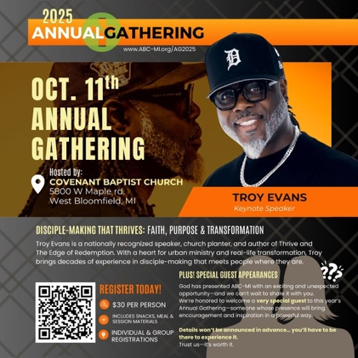

📅 Saturday, October 11 | Covenant Baptist Church, West Bloomfield
Get ready for a day of worship, equipping, and inspiration at our Annual Gathering!

🎤 Keynote Speaker: Troy Evans, a nationally recognized speaker and church planter, bringing fresh insight into disciple-making that thrives.
✨ PLUS: A special guest appearance you won’t want to miss!

👉 Registration includes meals, snacks, and materials: https://tithe.ly/event-registration/#/10298705

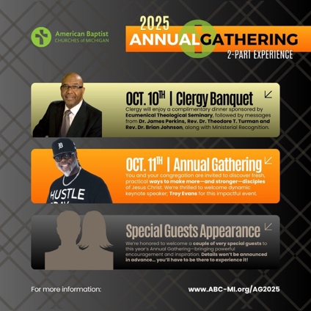

This year’s Annual Gathering is a two-part experience! 🙌

📅 Friday, Oct. 10 – Clergy Banquet (clergy + spouses)
📅 Saturday, Oct. 11 – Annual Gathering (open to clergy, leaders, and members)

Both days offer something unique—make sure you register for each individually.
✨ And yes… there will be special guests joining us!

👉 Learn more & register: https://www.abc-mi.org/ag2025

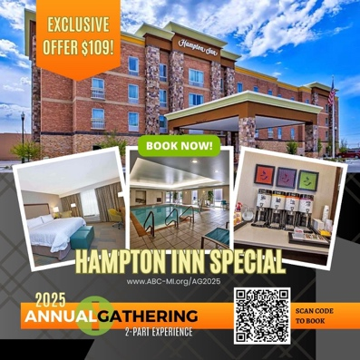

✨ Traveling in for the Annual Gathering? We’ve got you covered!

🏨 Stay at the Hampton Inn in West Bloomfield for an exclusive group rate of $109/night. Relax, refresh, and enjoy the full weekend with us!

📅 Space is limited, so book early: https://www.hilton.com/en/attend-my-event/dttwbhx-910-26fad07e-8c7f-4357-bec4-6fa09f23c7d5/

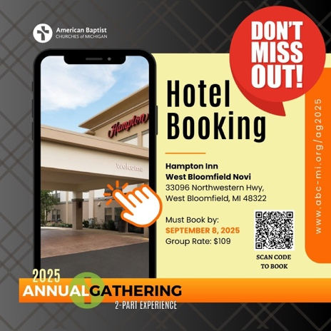

🚨 Don’t miss out! 🚨
Book your stay for the Annual Gathering at the Hampton Inn West Bloomfield for just $109/night.

📅 Deadline to reserve: September 8, 2025
📍 33096 Northwestern Hwy, West Bloomfield, MI

👉 Scan the code or click here to book: https://www.hilton.com/en/attend-my-event/dttwbhx-910-26fad07e-8c7f-4357-bec4-6fa09f23c7d5/

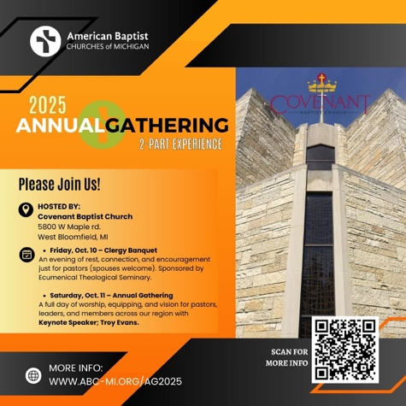

📅 October 10–11 | Covenant Baptist Church
Join us for a powerful 2-part Annual Gathering:

✨ Friday, Oct. 10 – Clergy Banquet (clergy + spouses)
✨ Saturday, Oct. 11 – Annual Gathering with keynote speaker Troy Evans

And don’t forget—special guest appearances you’ll only experience if you’re there! 👀
👉 More info & registration: https://www.abc-mi.org/ag2025

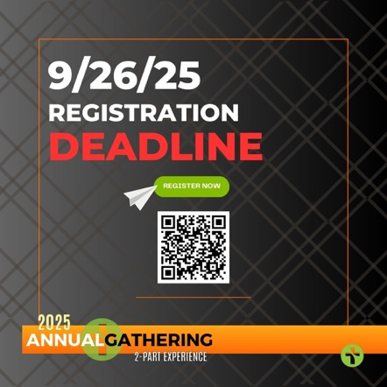

⏰ The clock is ticking! ⏰
The registration deadline for this year’s Annual Gathering is September 22, 2025.

Don’t wait—secure your spot today for this unforgettable weekend of worship, equipping, and encouragement.

👉 Register here: https://www.abc-mi.org/ag2025

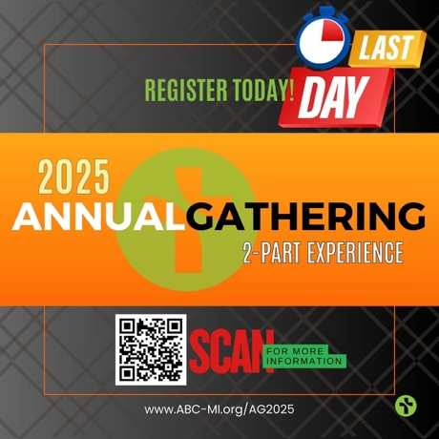

🚨 LAST CALL! 🚨
Today is your final chance to register for the 2025 Annual Gathering.

📅 Oct. 10 – Clergy Banquet (clergy + spouses)
📅 Oct. 11 – Annual Gathering (open to all)

Don’t miss this two-day experience of renewal, connection, and vision.
👉 Register now: https://www.abc-mi.org/ag2025

