UNITED STEWARDSHIP PLAN
ABMS Category | ABMS Category Code | Category Definition
United Mission Basics | UMB | a. Giving through the avenue of United Mission shall remain the priority as other new sources of funding are explored.  b. Upon implementation of the Common Budget Covenant, any Region may begin retaining a maximum of 65% of Net United Mission. Any Region choosing to receive less than the maximum of 65% at the outset may increase up to 2% per year provided that the respective Region Board report its intent to the Office of the General Secretary nine months ahead of a new fiscal year.
ABWM Love Gift | LG | Love Gift shall continue to be promoted by American Baptist Women’s Ministries and shall be included in United Mission. An equivalent of 15% of Love Gift will be allocated for the operation of American Baptist Women’s Ministries.
America for Christ Offering | AFC | a. The promotional window for this offering shall be during the months of February - March.  b. Collecting Agents may receive contributions to this offering throughout the year.  c. Promotional costs for the America for Christ Offering shall not exceed 8% of the gross receipts from the offering.  d. After promotional costs have been deducted, monies received from the offering shall be distributed one-third to the respective Region and two-thirds to National Ministries.
World Mission Offering | WMO | a. The promotional window for this offering shall be during the months of September - October.  b. Collecting Agents may receive contributions to this offering throughout the year.  c. After promotional costs not to exceed 8% have been deducted, monies received from this offering shall be used at the discretion of the Board of International Ministries. Promotional costs will be paid by the Board of International Ministries.  d. Directed Giving is permissible throughout the year and will be credited toward the intended cause as directed by the gift.
Retired Ministers & Missionaries Offering | RMO | a. The promotional window for this offering shall be during the months of November - December.  b. Collecting Agents may receive contributions to this offering throughout the year.  c. The offering is used by MMBB to provide assistance for retired ministers and missionaries. Promotional costs, not to exceed 8%, will be paid by MMBB.
One Great Hour of Sharing | OGH | a. The promotional window for this offering shall be during the months of May - June. In the case of national or international disasters relief information may be communicated to the churches and individuals outside the window.  b. Collecting Agents may receive contributions to this offering throughout the year.  c. After promotional costs, not to exceed 8%, have been deducted, monies received from this offering shall be distributed by the World Relief Committee.  d. Directed Giving is permissible throughout the year and will be credited toward the intended cause as directed by the gift.
Region Offering | RO | a. Regions choosing to receive a Region offering shall promote this offering during any two-month window that does not conflict with the promotional periods for AFC and WMO.  b. Collecting Agents may receive contributions to this offering throughout the year.  c. Monies received from this offering shall be used at the discretion of the respective Region. Promotional costs will be paid by the respective Region at a rate not to exceed 8% of the offering. The promotional cost limit becomes effective after the establishment of the offering (a period not to exceed five years).  d. Directed Giving is permissible throughout the year and will be credited toward the intended cause as directed by the gift.
Institutional Support | ISP | Institutions that are part of ISP may raise funds from all ABC churches. Special campaigns should be negotiated with individual partners to the Common Budget Covenant.
Specifics | SPC | Collecting Agents may receive specific gifts throughout the year. Monies received will be forwarded to the appropriate agency as directed by the gift.
Targeted Giving | TG | Appeals for targeted gifts may be made throughout the year. All appeals, however, shall indicate that such gifts are intended to be over and above United Mission and the Annual Offerings. Additionally, to ensure that the appeals do not interfere with the needs and interests of local congregations within a particular Region and to maximize region support, Regions are to be notified as to the purpose of all targeted giving strategies at least one month ahead of the appeal. For appeals to individuals, regions will be notified in advance of the appeal. Promotional timelines may need to be negotiated between Regions and the Program Boards in the event of potential conflicts.
Campaigns for ABC Work | CGN | Special campaigns are those that do not contribute to the annual operating revenue for the organization, but are integral to the long-term financial health of Regions, related National Boards, and the Office of the General Secretary. Increasingly, traditional capital funds campaigns, limited to a specific period of time that seldom exceeds 3-5 years in which the full pledge amount is realized, are supplemented with deferred giving campaigns. This style is known as an integrated campaign.
Miscellaneous Objectives | MO | This category provides a channel for sending gifts to American Baptist missionaries for their personal use, as well as to the American Bible Society. Other non-ABC-related gifts should be sent directly to the organization. Gifts in this category are treated as “pass-through” gifts and are not tax deductible.
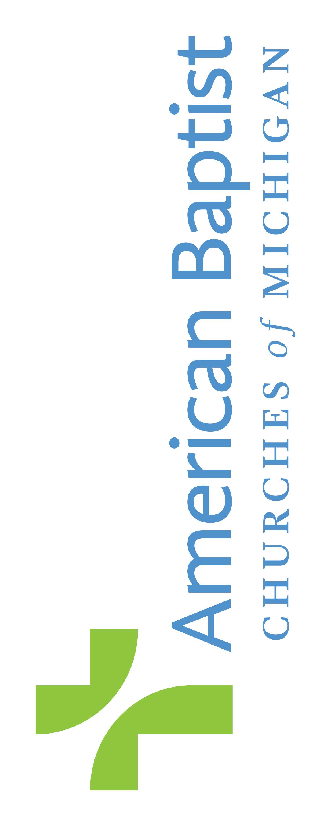
American Baptist Mission Support
Annual Offerings
Monthly Remittance of Mission Support
Report for Month of |  |  |  |  |  | Year
Church Name/Donor:
Association/Area: |  |  |  |  | PIN:
Credit Receiver (Name):
Phone:
E-Mail:
Region: | American Baptist Churches of Michigan
To use window envelope mailing address must be below line or fold must be where marked below. Send Receipt To:

Treasurer:
Address:
City: |  |  |  |  | State |  | Zip
E-Mail
Treasurer Phone:
Mail Remittance Report and Check Payable to:
American Baptist Churches of Michigan
4578 South Hagadorn Road
East Lansing, MI 48823

Phone: 800.632.2953
FAX: 517.332.3186
Region E-mail: drhodes@abc-mi.org
For Office Use Only
Date Received ________________________
Receipt Number ______________________
Check # ______________Staff___________
UNITED MISSION Code
United Mission Basics UMB ______________
United Mission AB Women’s Ministries Love Gift LG ______________
Total United Mission Giving…………………….........................................................................$______________

ABC-MI Region Offering RO ______________
America for Christ Offering AFC ______________
One Great Hour of Sharing Offering …………..(regular OGHS giving)$____________
OGHS Directed Giving (please list below)
_________________________________________ ____________________ $____________
Total One Great Hour of Sharing (Use additional forms if space is not available.) OGH ______________

Retired Ministers and Missionaries Offering RMO ______________
World Mission Offering …………...(Regular WMO Giving)$____________
WMO Directed Giving (please list below)
_________________________________________ ____________________ $____________
_________________________________________ ____________________ $____________
Total WMO Directed Giving (Use additional forms if needed) $____________
Total World Mission Offering WMO ______________

Institutional Support (as listed below)
Northern Baptist Theological Seminary_____ ____________________ $____________
Judson University_________________________ ____________________ $____________
American Baptist Assembly________________ ____________________ $____________
_________________________________________ ____________________ $____________
_________________________________________ ____________________ $____________
Total Institutional Support (Use additional forms if needed) ISP ______________
Specifics (as listed below)
American Baptist Churches of Michigan (budgeted) ____________________ $____________
Camp Lael ____________________ $____________
Higher Ground - Lake Louise ____________________ $____________
Friendship House Ministries ____________________ $____________
Ministry Leadership Groups ____________________ $____________
Michigan Baptist Scholarship Society ____________________ $____________
_____________________________________ ____________________ $____________
_________________________________________ ____________________ $____________
Total Specifics (Use additional forms if needed) …………….. SPC ______________
Targeted Giving
_________________________________________ ____________________ $____________
_________________________________________ ____________________ $____________
Total Targeted Giving TG ______________
Total American Baptist Mission Support $ ______________

ABC Campaigns __________________________________________________ CGN ______________
Miscellaneous Objectives
_________________________________________ ____________________ $____________
_________________________________________ ____________________ $____________
Total Miscellaneous Objectives MO ______________
REMITTANCE TOTAL Verify Check Amount $ _____________________

Thank you for your mission support dollars! Although every effort is made to comply with donor wishes, tax deductible contributions are received with the understanding that ABCUSA and ABC-MI have complete discretion and control over the use of all donated funds. Retain a copy of this form as submitted for your records. Monthly reports will be mailed to confirm posting. Please report any errors/changes by calling 800-632-2953.

Fold mark

